**Project Report**

**Title:** Early Detection of Chronic Kidney Disease using Machine Learning

**Team ID:** PNT2022TMID48683

**Introduction**

**Project Overview**

**Chronic kidney disease, also called chronic kidney failure, describes the gradual loss of kidney function. Your kidneys filter wastes and excess fluids from your blood, which are then excreted in your urine. When chronic kidney disease reaches an advanced stage, dangerous levels of fluid, electrolytes and wastes can build up in your body.**

In the early stages of chronic kidney disease, you may have few signs or symptoms. Chronic kidney disease may not become apparent until your kidney function is significantly impaired.

Treatment for chronic kidney disease focuses on slowing the progression of the kidney damage, usually by controlling the underlying cause. Chronic kidney disease can progress to end-stage kidney failure, which is fatal without artificial filtering (dialysis) or a kidney transplant.

**Purpose**

* To predict the disease early and to take the precautions in advance
* To have a better glance about the patient health condition
* To know the severity of chronic kidney disease in early stage
* Reducing the cost that taken to measure these disease
* Make a more reliable way to measure chronic kidney disease

**Literature Survey**

**Existing Problem**

1. To measure the glomerular filtration rate (GFR) in adults and children with cystic fibrosis (CF) using a radio-isotope technique as the gold standard and to compare this to serum creatinine based equations, serum cystatin C levels and tobramycin clearance, and to determine which method correlates most closely with measured GFR in this population.
2. The main limitation of the eGFR formulas is significant lack of accuracy in individuals as compared to groups. This causes problems in establishing the presence or absence of early CKD
3. Unfortunately, the initial creatinine tests can lead to misdiagnosis and inappropriate treatment.” Misdiagnoses appear to be common, according to the researchers' review of the electronic health records of 3.8 million emergency and intensive care patients.

**References**

[1] “9 Symptoms of Type 1 & Type 2 Diabetes: Complications, Causes & Diet”, MedicineNet, 2019. [Online]. Available: https://www.medicinenet.com/diabetes mellitus/article.htm [Accessed: 05- Jul- 2019].

[2] “International Diabetes Federation - What is diabetes”, Idf.org, 2019. [Online]. Available: https://www.idf.org/aboutdiabetes/what-isdiabetes.html. [Accessed: 08- Jul- 2019].

[3] “Statistics About Diabetes”, Diabetes.org, 2019. [Online]. Available: <https://www.diabetes.org/resources/statistics/statistics-about-diabetes>. [Accessed: 10- Jul- 2019].

[4] R. Hira, M. Miah and D. Akash, “Prevalence of Type 2 Diabetes Mellitus in Rural Adults (¿ 31years) in Bangladesh”, Faridpur Medical

College Journal, vol. 13, no. 1, pp. 20-23, 2018. [Accessed 16 July 2019].

[5] “Machine Learning - Definition and application examples”, Spotlightmetal.com, 2019. [Online]. Available: <https://www.spotlightmetal.com/machine-learning–definition-andapplication-examples-a-746226/> [Accessed: 17- Jul- 2019].

[6] A. Mir and S. Dhage, “Diabetes Disease Prediction Using Machine Learning on Big Data of Healthcare”, in 2018 Fourth International Conference on Computing Communication Control and Automation (ICCUBEA), Pune, India, 2018.

[7] D. Dutta, D. Paul and P. Ghosh, “Analysing Feature Importances for Diabetes Prediction using Machine Learning”, in 2018 IEEE 9th Annual Information Technology, Electronics and Mobile Communication Conference (IEMCON), Vancouver, BC, Canada, 2018.

[8] M. Raihan, Muhammad Muinul Islam, Promila Ghosh, Shakil Ahmed Shaj, Mubtasim Rafid Chowdhury, Saikat Mondal, Arun More, “A Comprehensive Analysis on Risk Prediction of Acute Coronary Syndrome Using Machine Learning Approaches“, in 2018 21st International Conference of Computer and Information Technology (ICCIT), Dhaka, Bangladesh, 2018, pp. 1 - 6.

[9] D. Kinge and S. Gaikwad, “Survey on data mining techniques for disease prediction”, International Research Journal of Engineering and Technology (IRJET), vol. 05, no. 01, pp. 630-636, 2018. [Accessed 21 July 2018].

[10] S. Manna, S. Maity, S. Munshi and M. Adhikari, “Diabetes Prediction Model Using Cloud Analytics”, in 2018 International Conference on Advances in Computing, Communications and Informatics (ICACCI), Bangalore, India, 2018.

[11] D. Verma and N. Mishra, “Analysis and prediction of breast cancer and diabetes disease datasets using data mining classification techniques ”, in 2017 International Conference on Intelligent Sustainable Systems (ICISS), Palladam, India, 2017.

[12] W. Xu, J. Zhang, Q. Zhang and X. Wei, “Risk prediction of type II diabetes based on random forest model”, in 2017 Third International Conference on Advances in Electrical, Electronics, Information, Communication and Bio-Informatics (AEEICB), Chennai, India, 2017.

[13] H. Emblem, “When to use a Trimmed Mean”, Medium, 2018. [Online]. Available: <https://medium.com/@HollyEmblem/when-to-usea-trimmedmean-fd6aab347e46> [Accessed: 24-Jul-2019].

[14] “TrimMean function R Documentation”,Rdocumentation.org. [Online].Available: [www.rdocumentation.org/packages/sscore/versions/1.44.0/topics/trimMean](http://www.rdocumentation.org/packages/sscore/versions/1.44.0/topics/trimMean) [Accessed: 25-Jul-2019].

[15] “Median”, RDocumentation, 2019. [Online]. Available:https://www.rdocumentation.org/packages/stats/versions/3.5.2/topics/median [Accessed: 01- Aug- 2019].

[16] H. Kandan, “Bagging the skill of Bagging(Bootstrap aggregating).”, Medium, 2018. [Online]. Available:

<https://medium.com/@harishkandan95/bagging-the-skill-of-baggingbootstrap-aggregating-83c18dcabdf1> [Accessed: 04- Aug- 2019].

**Problem Statement Definition**

Chronic kidney disease includes conditions that damage your kidneys and decrease their ability to keep you healthy by filtering wastes from your blood. If kidney disease worsens, wastes can build to high levels in your blood and make you feel sick. You may develop complications like:

* high blood pressure
* anemia (low blood count)
* weak bones
* poor nutritional health
* nerve damage

Kidney disease also increases your risk of having heart and blood vessel disease. These problems may happen slowly over a long time. Early detection and treatment can often keep chronic kidney disease from getting worse. When kidney disease progresses, it may eventually lead to kidney failure, which requires dialysis or a kidney transplant to maintain life.

**Ideation & Proposed Solution**

**Empathy Map Canvas**

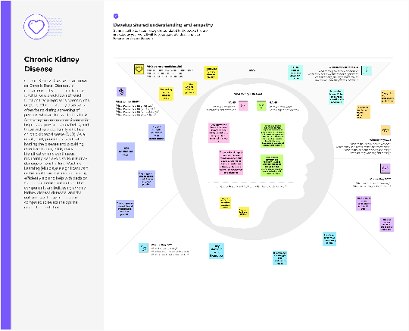

**Proposed Solution**

Chronic Kidney Disease, also known as Chronic Renal Disease, is characterized by abnormal kidney function or a breakdown of renal function that progresses over months or years. Chronic kidney disease is often found during screening of persons who are known to be at ris for kidney issues, such as those wis high blood pressure or diabetes, and those with a blood family who has chronic kidney disease (CKD). As a result, early prognosis is critical in battling the disease and providing effective therapy. Only early identification and continuous monitoring can avoid serious kidney damage or renal failure. Machine Learning (ML) plays a significant part in the healthcare system, and it may efficiently aid and help with decision support in medical institution. The components are built using chronic kidney disease datasets, and the outcomes of these models are compared to select the optimai model for prediction.

**Problem Solution Fit**

or need to get the job done? What have they tried in the past? What pros & cons do these solutions have?

Analyzing a sample of your urine (urinalysis) may reveal abnormalities that suggest kidney failure and taking blood test but it not much reliable because it doesn’t show exactly whether the person is under worse condition.

**AS**

**5. AVAILABLE SOLUTIONS**

Which solutions are available to the customers when they face the problem

What constraints prevent your customers from taking action or limit their choices

of solutions?

The began to reduce their chance of finding best solutions and also take the words of neighbors, others could limit their possibilities of taking best decisions under those circumstances

**CC**

**6. CUSTOMER CONSTRAINTS**

**CS**

**1. CUSTOMER SEGMENT(S)**

Who is your customer?

Globally kidney chronic disease is a thread and also it is hard to know whether the persons is affected or not hence the customers in this topic is global persons who wants to know he/she is affected by chronic disease

**Explore AS, differentiate**

**Define CS, fit into CC**

The best method to reduce the risk of kidney chronic is to predict it earlier which will make great impact to take much cause to prevent or safe guard from the hazardous stage. The internet is wide open now a days so make the prediction via online is much more reliable for persons

**BE**

**7. BEHAVIOUR**

What does your customer do to address the problem and get the job done?

**RC**

**9. PROBLEM ROOT CAUSE**

What is the real reason that this problem exists? What is the back

story behind the need to do this job?

Diabetes and high blood pressure, or hypertension, are responsible for two-thirds of chronic kidney disease cases. Doesn’t taking much precautions for those disease will lead them to renal affection

**J&P**

**2. JOBS-TO-BE-DONE / PROBLEMS**

Which jobs-to-be-done (or problems) do you address for your customers? There could be more than one; explore different sides.

The major thread of kidney chronic disease is that it is unknow before till it becomes worse condition so our solution implies the best method to predict whether the host is affected by chronic disease in the real time and choose to take further cause for that

**Focus on J&P, tap into BE, understand RC**

**Focus on J&P, tap into BE, understand RC**

|  |  |  |  |  |
| --- | --- | --- | --- | --- |
| **Identify strong TR & EM** | **3. TRIGGERS TR**  What triggers customers to act?  Diabetes is the most common cause of kidney disease. Both type 1 and type 2 diabetes. But also heart disease and obesity can contribute to the damage that causes kidneys to fail. Urinary tract issues and inflammation in different parts of the kidney can also lead to long-term functional decline | **10. YOUR SOLUTION SL**  If you are working on an existing business, write down your current solution ﬁrst, ﬁll in the canvas, and check how much it ﬁts reality.  End stage renal disease (ESRD) describes the most severe stage of chronic kidney disease (CKD), when patients need dialysis or renal transplant. There is often a delay in recognizing, diagnosing, and treating the various etiologies of CKD. The objective of the present study was to employ machine learning algorithms to develop a prediction model for progression to ESRD based on a large-scale multidimensional database  we will be going through the Chronic kidney disease dataset and doing the complete analysis on the same our main goal will be to predict whether an individual will have chronic kidney disease or not based on the data provided. | 1. **CHANNELS of BEHAVIOUR CH**     1. **ONLINE**   What kind of actions do customers take online? Extract online channels from #7  **Via a web application the prediction goes on and it takes some parameters of persons to calculate**   * 1. **OFFLINE**   **Taking offline requirements such as health data of persons makes the prediction much more accurate to predict** |  |
| **4. EMOTIONS: BEFORE / AFTER EM**  How do customers feel when they face a problem or a job and afterwards?  They started to loss their control when they face the problem before and after that condition they loss their ability to take control over situations |

**Requirement Analysis**

**Functional Requirement**

|  |  |  |
| --- | --- | --- |
| **FR No.** | **Functional Requirement (Epic)** | **Sub Requirement (Story / Sub-Task)** |
| FR-1 | User Registration | Registration through Google account  Registration through Google forms |
| FR-2 | User Confirmation | Confirmation via Google |
| FR-3 | User Medical Data | Amount of blood sugar, Blood urea, Coronary Disease, Pus cells, Petal edema, Diabetes mellitus, Red blood cells, Anemia |
| FR-4 | User Payment options | Gpay, Phonepe, Net banking for payments to the developer and product level basis of this project |
|  |  |  |
|  |  |  |

**Non-Functional Requirement**

|  |  |  |
| --- | --- | --- |
| **FR No.** | **Non-Functional Requirement** | **Description** |
| NFR-1 | **Usability** | The usability of the project is easy and user friendly environment to the user to interact with it |
| NFR-2 | **Security** | The data of users are well preserved and there is no any other third parties to gather the information of user |
| NFR-3 | **Reliability** | User can use the product across any platform in the market |
| NFR-4 | **Performance** | The performance of the machine learning model used to predict the disease is much accurate |
| NFR-5 | **Availability** | It can available on global level market and also in all medical devices and non-medical devices to predict the disease |
| NFR-6 | **Scalability** | In the future we can develop the model and user interface of our product to enhance the functionality and parameters. Medical parameters are added further to predict much more other disease |

**Project Design**

**Data flow Diagram Solution and Technical Architecture**

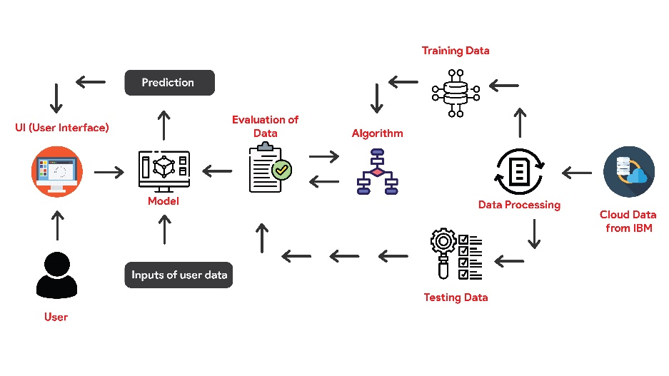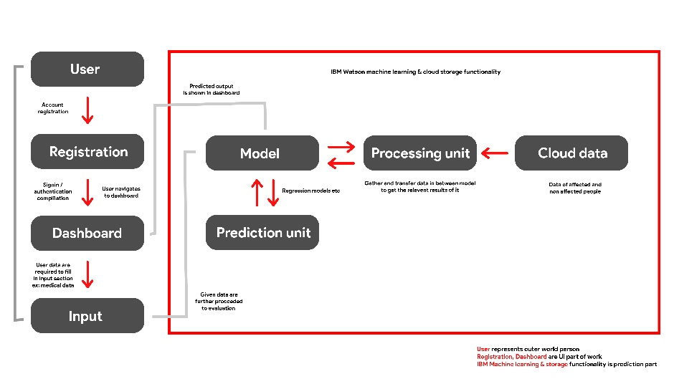

|  |  |  |  |
| --- | --- | --- | --- |
| **S.No** | **Component** | **Description** | **Technology** |
|  | User Interface | Web UI, Mobile App | Flutter (Dart) |
|  | Application Logic-1 | To integrate API or API is directly used in flutter | Python |
|  | Application Logic-2 | To manage data package that initially stored in local | IBM Cloud object storage |
|  | Application Logic-3 | To predict and give the desired output of what we build for | IBM Watson machine learning |
|  | Database | Data is fed into watson cloud storage to process the data online in anytime in .csv format | IBM cloud storage |
|  | Cloud Database | Database Service on Cloud | IBM cloud storage |
|  | External API-1 | API used to gather the results that model predicts and also carry the output in dashboard of web or mobile application | IBM API |
|  | Machine Learning Model | This hard core part used to build the model based on application | Random Forest model |
|  | Infrastructure (Cloud) | Application Deployment on Cloud  Cloud Server Configuration: Firebase (Google) | Firebase |

| **S.No** | **Characteristics** | **Description** | **Technology** |
| --- | --- | --- | --- |
|  | Open-Source Frameworks | Flutter is open source UI frame work used now a days by many of the developers because it provides rich UI | Flutter (Dart) |
|  | Security Implementations | Since firebase is growing It provides best services for multiple platform applications with easy structural implementation | SHA certification in firebase |
|  | Scalable Architecture | Since we used flutter as UI frame work, It has the most advantages because it can be used to develop cross platform applications in single code base | Flutter and firebase |
|  | Availability | Application build for our project is hosted in web, mobile platforms | Web application, Play store, App store |
|  | Performance | The performance of flutter is best in market available at current time and also model that we build for machine learning given a well optimized performance with greater accuracy | Flutter, Random forest model in machine learning, ML deployment in IBM watson machine learning, Fire base for web and mobile application hosting |

**Project Planning & Scheduling**

**Sprint Planning and Estimation**

| **Sprint** | **Functional Requirement (Epic)** | **User Story Number** | **User Story / Task** | **Story Points** | **Priority** | **Team Members** |
| --- | --- | --- | --- | --- | --- | --- |
| Sprint-1 | Registration | USN-1 | User can sign in to our web application by using google account | 12.5 | High | Mohamed Ibrahim, Mohamed Asif, Prabhu, Kamalesh |
| Sprint-1 |  | USN-2 | Users are considered to fill the google form for further authentication | 12.5 | Medium | Mohamed Ibrahim, Mohamed Asif, Prabhu, Kamalesh |
| Sprint-1 |  | USN-3 | User log in data is stored and surveillance by google firebase authentication service | 12.5 | High | Mohamed Ibrahim, Mohamed Asif, Prabhu, Kamalesh |
| Sprint-1 | Login | USN-4 | User now successfully registered using google authentication service | 12.5 | High | Mohamed Ibrahim, Mohamed Asif, Prabhu, Kamalesh |
| Sprint-2 | Dashboard | USN-5 | Now user is preferred to enter the medical details to analyse their disease severity or whether they have that disease | 12 | High | Mohamed Ibrahim, Mohamed Asif, Prabhu, Kamalesh |
| Sprint-3 | Dashboard | USN-6 | There are three values which should be given in float or numerically | 11.8 | High | Mohamed Ibrahim, Mohamed Asif, Prabhu, Kamalesh |
| Sprint-3 | Dashboard | USN-7 | There are some other valuers which are fulfilled by alpha values whether they have or not (yes or no questions) | 12 | High | Mohamed Ibrahim, Mohamed Asif, Prabhu, Kamalesh |
| Sprint-4 | Dashboard | USN-8 | After fulfilment of user medical values the prediction of disease is analysed by machine learning model that present in the IBM Watson machine learning platform | 12.5 | High | Mohamed Ibrahim, Mohamed Asif, Prabhu, Kamalesh |

**Sprint Delivery Schedule**

| **Sprint** | **Total Story Points** | **Duration** | **Sprint Start Date** | **Sprint End Date (Planned)** | **Story Points Completed (as on Planned End Date)** | **Sprint Release Date (Actual)** |
| --- | --- | --- | --- | --- | --- | --- |
| Sprint-1 | 12.5 | 4 Days | 20 Oct 2022 | 24 Oct 2022 | 12.5 | 24 Oct 2022 |
| Sprint-2 | 12.5 | 4 Days | 24 Oct 2022 | 28 Oct 2022 | 12 | 29 Oct 2022 |
| Sprint-3 | 12.5 | 3 Days | 28 Oct 2022 | 2 Nov 2022 | 11.9 | 2 Nov 2022 |
| Sprint-4 | 12.5 | 4 Days | 2 Nov 2022 | 6 Nov 2022 | 12.5 | 5 Nov 2022 |

**Burndown Charts**

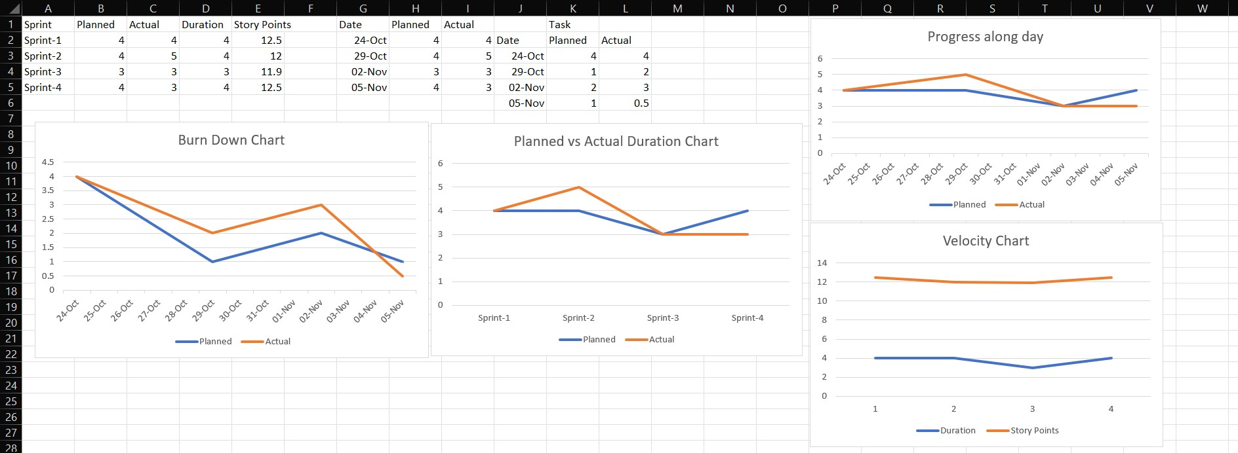

**Coding & Solution**

**Feature 1**

Full code link is attached below

<https://www.mediafire.com/file/0pjvai3irreddfh/chronic-kidney-disease-clustering-and-prediction.ipynb/file>

**Testing**

**Test cases**

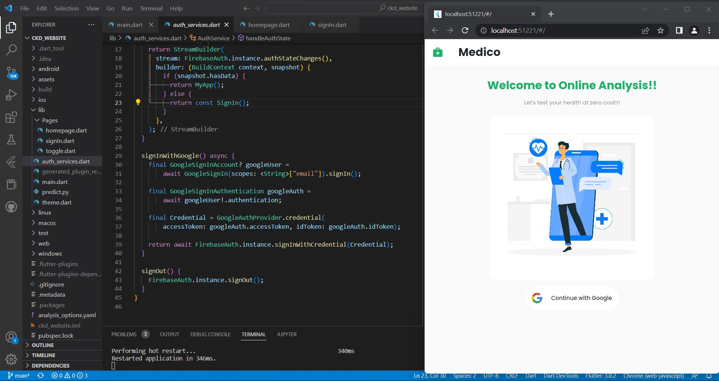

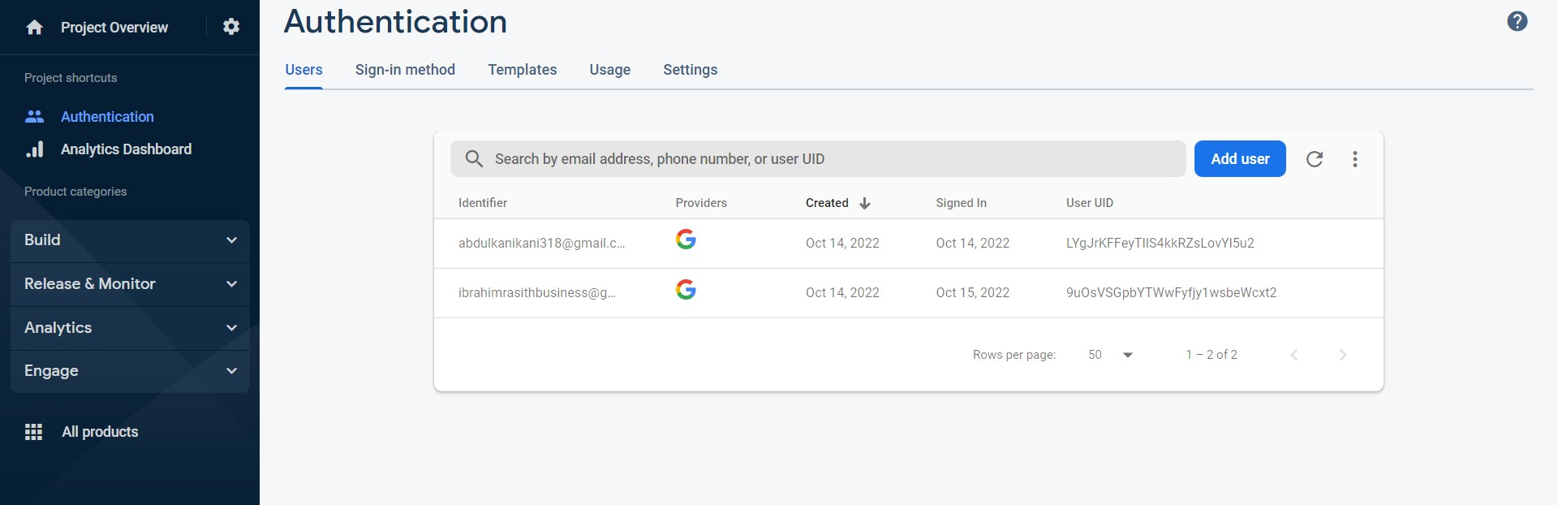

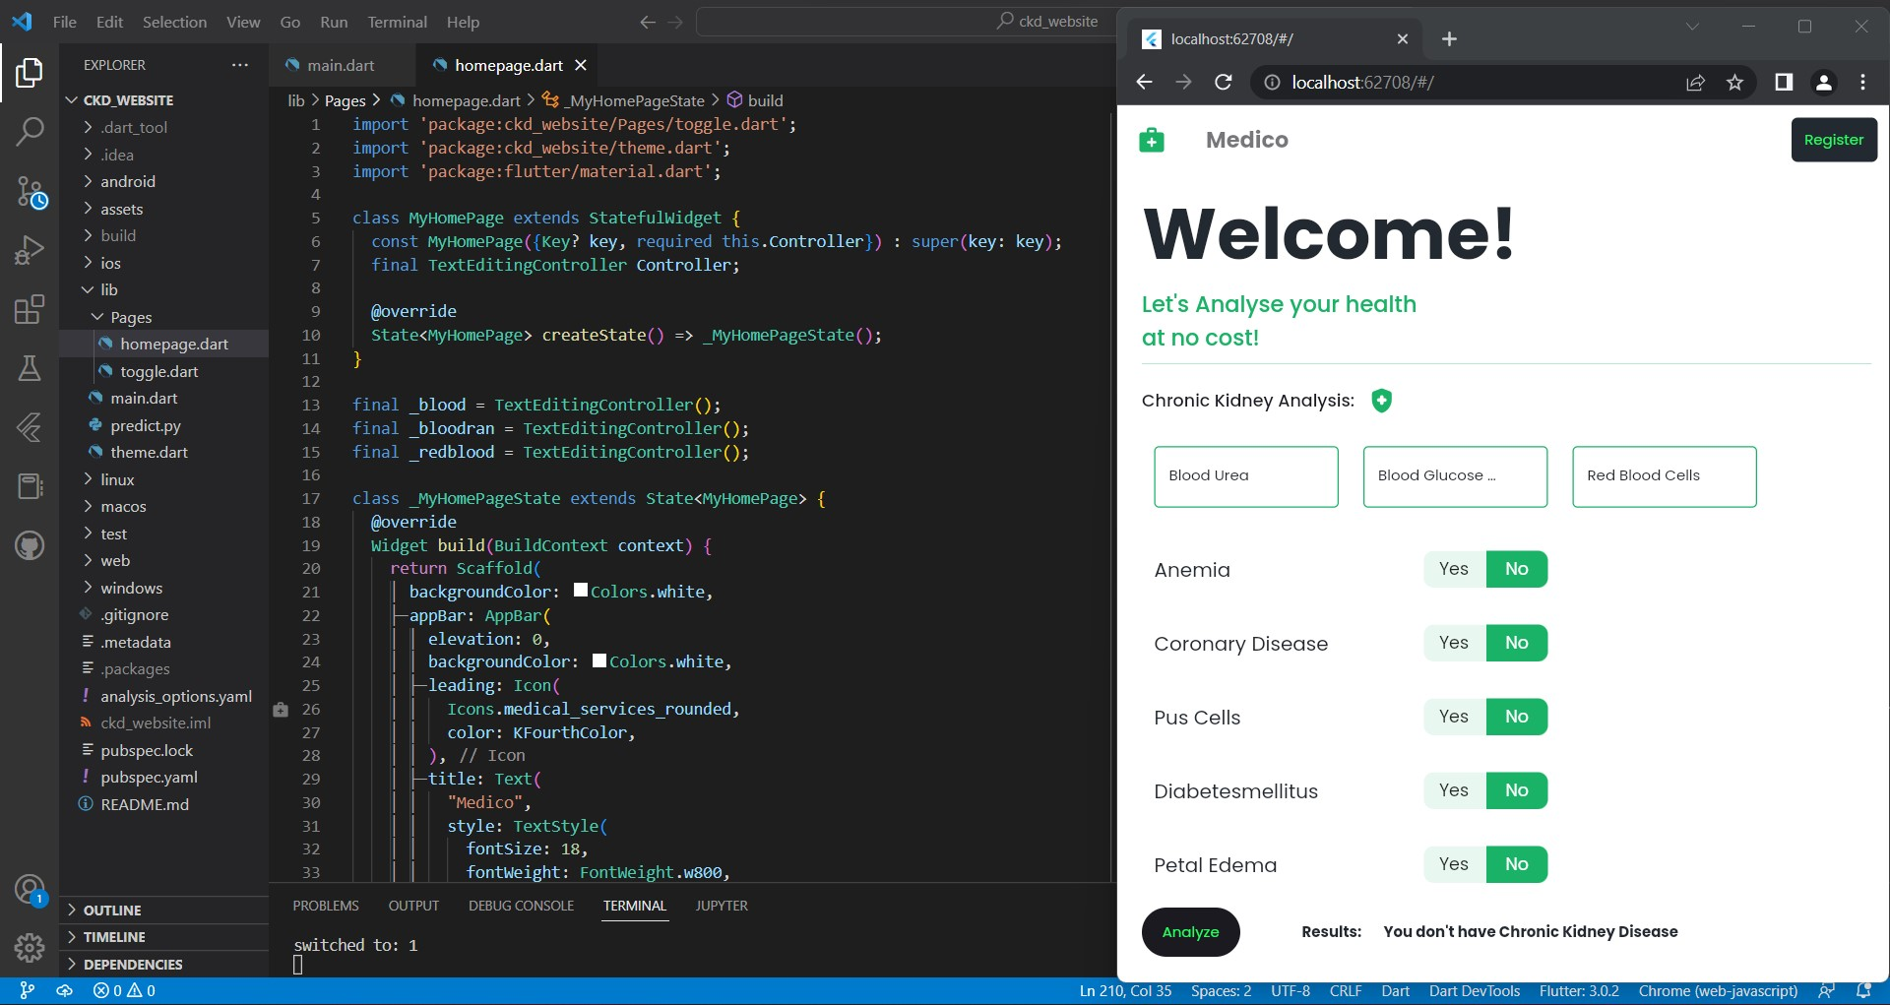

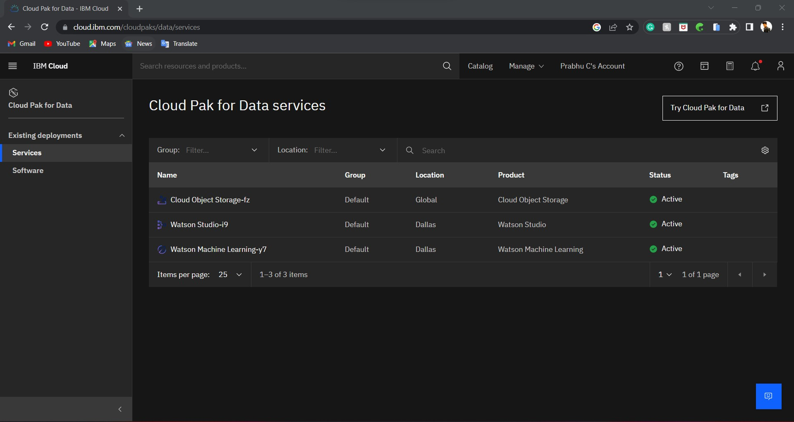

**Results**



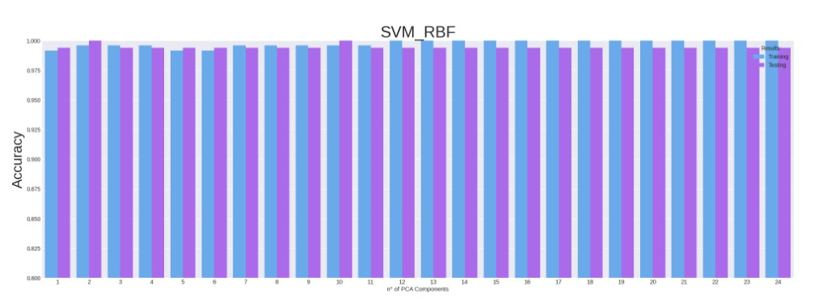

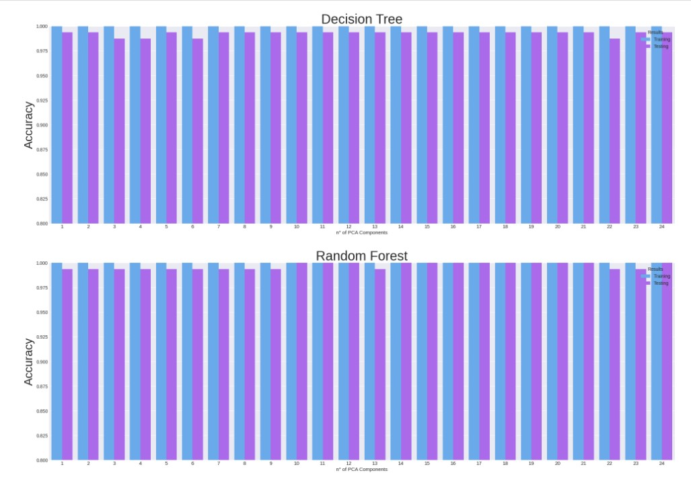

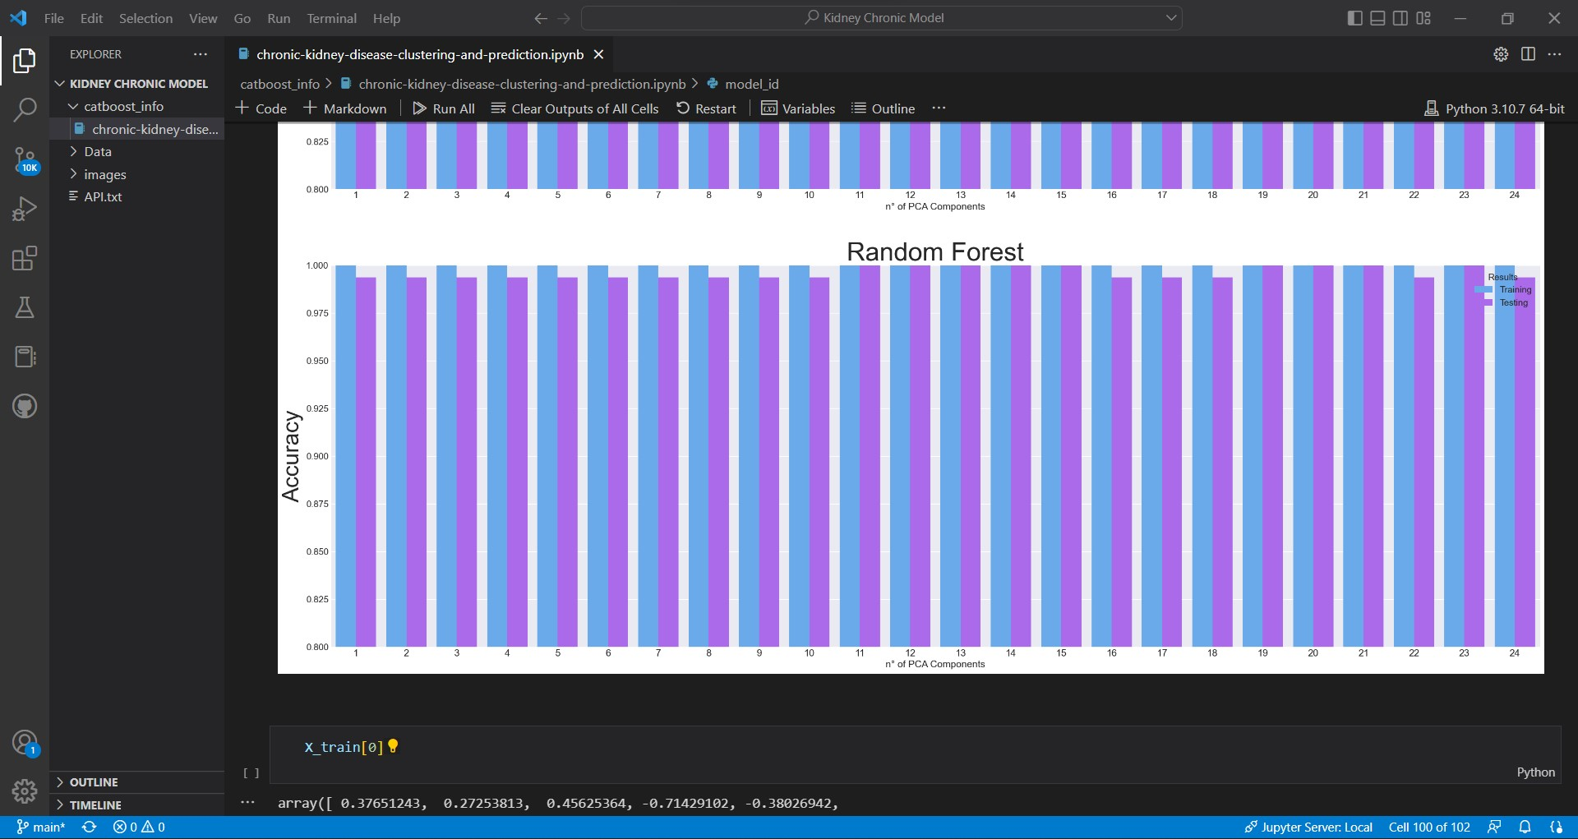

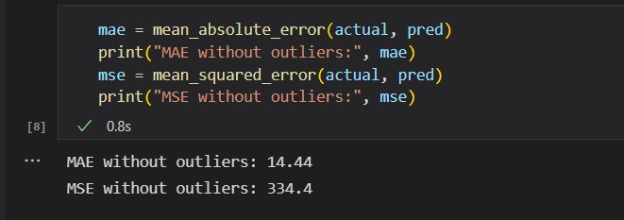

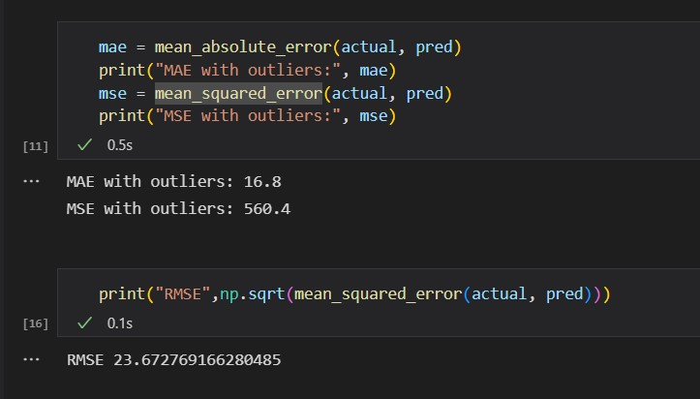

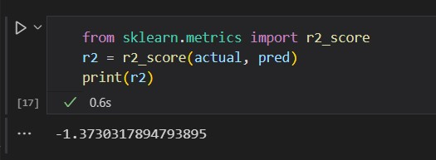

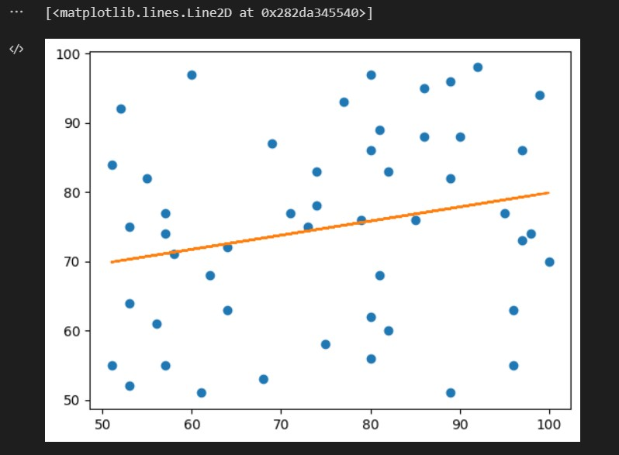 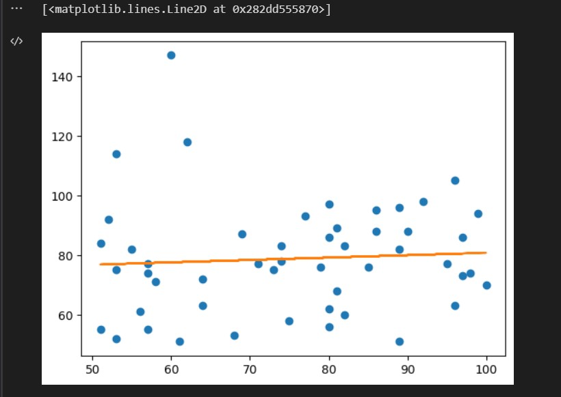

**Advantages & Disadvantages**

**Advantages**

* ML based algorithm has high accuracy in predicting kidney disease
* Using Big Data the chance of working progression is improved
* The model build has high performance in accuracy and gives better results
* Thus introducing into clinical field can prevent patients from severeness of chronic kidney disease
* The indication of kidney chronic disease shows the severeness according to that treatment can be done
* The time consuming is also reduced hence relevant action can be taken
* Constant remembrance of kidney health via online
* Machine Learning has enormous efficiency in data handling
* The chance of human error is less
* Machine learning in healthcare can also be used to improve the quality of patient care.

**Disadvantages**

* Gaps in healthcare data can lead to inaccurate forecasts
* ML requires high-quality structured data to produce accurate predictions.

**Conclusion**

ML algorithms are a tool for unearthing the rules of big data, and prediction models which incorporate them have exceptional accuracy in predicting kidney disease patients’ poor prognosis during clinical practice. The use of ML algorithms can help clinicians detect patients at high risk of kidney function progression in the early stages. In this way, they can receive treatment and management in time. In sum, we suggest the gradual incorporation of ML algorithm-based prediction models into clinical practice.

**Future Scope**

* Machine Learning is the type of technology that keeps on evolving. There is a lot of scope in ML to become the top technology in the future. The reason is, it has a lot of research areas in it. This helps us to improve both **hardware** and **software**.
* In hardware, we have various laptops and GPUs. These have various ML and Deep Learning networks in them. These help in the faster processing power of the system. When it comes to software we have various UIs and libraries in use. These help in designing more efficient algorithms
* By improving and using ML in clinical sector will have huge potential over medical issues
* The medical issues can be prevented in time rather than comparing with traditional method of predicting
* Introducing bid data in medical field can improve effective way of handling and using it in useful progress over human health
* Further introducing blockchain in medial field can solve clinical data security and cause users a helpful way of growth by their own medical data

**Appendix**

**Source code**

**Model Building -** <https://github.com/mohamed8270/Machine-Learning-Kidney-Disease-Prediction-/tree/main/Kidney%20Chronic%20Model/Model%20Building>

**Frontend Features -** https://github.com/mohamed8270/Machine-Learning-Kidney-Disease-Prediction-/tree/main/Kidney%20Chronic%20Model/Application%20Building

**GitHub**

**IBM Project repo -** <https://github.com/IBM-EPBL/IBM-Project-48048-1660804120>

**GitHub repo -** https://github.com/mohamed8270/Machine-Learning-Kidney-Disease-Prediction-

**Demo Link -** <https://www.mediafire.com/file/d1rc9826dgkj73i/Demo.mp4/file>

**Video Link -** https://youtu.be/nTeslfRZvk8